Create a Storage Account

Basics

Choose the Subscription

Give them the Storage account name   
Select the region as a Asia Pacific

Keep other things as by default

Advance

Click on the Hierarchical Namespace  
Keep other things as by default

Networking

Keep other things as by default

Data Protection

Keep other things as by default

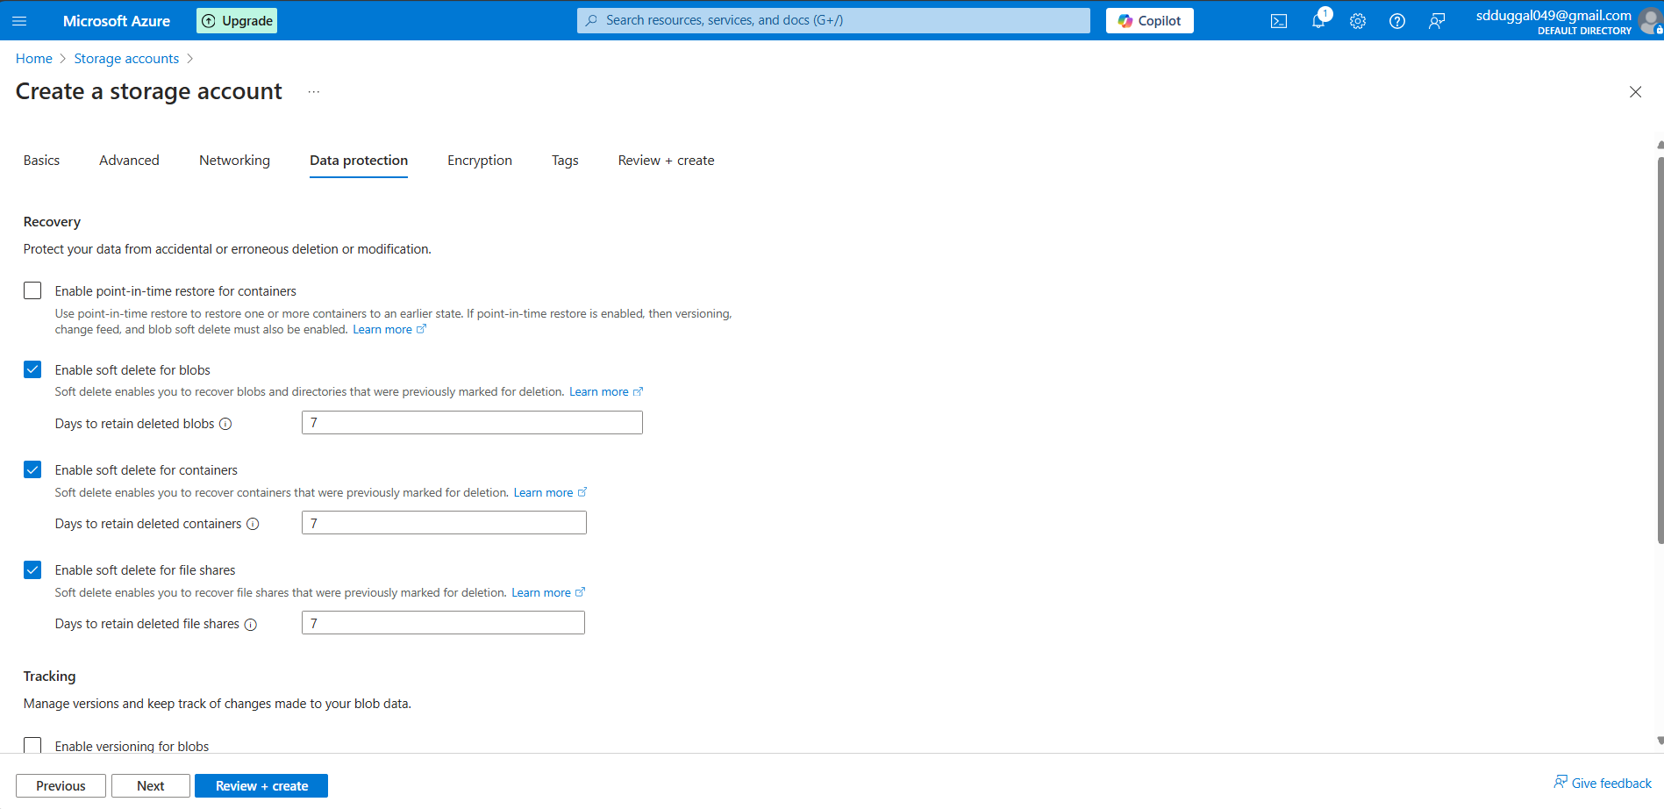

Encryption

Keep other things as by default

Tags

Keep other things as by default

Review + Create

Keep other things as by default

Click on Create   
So it will create a Storage Account for you  
  
It will take a few minutes

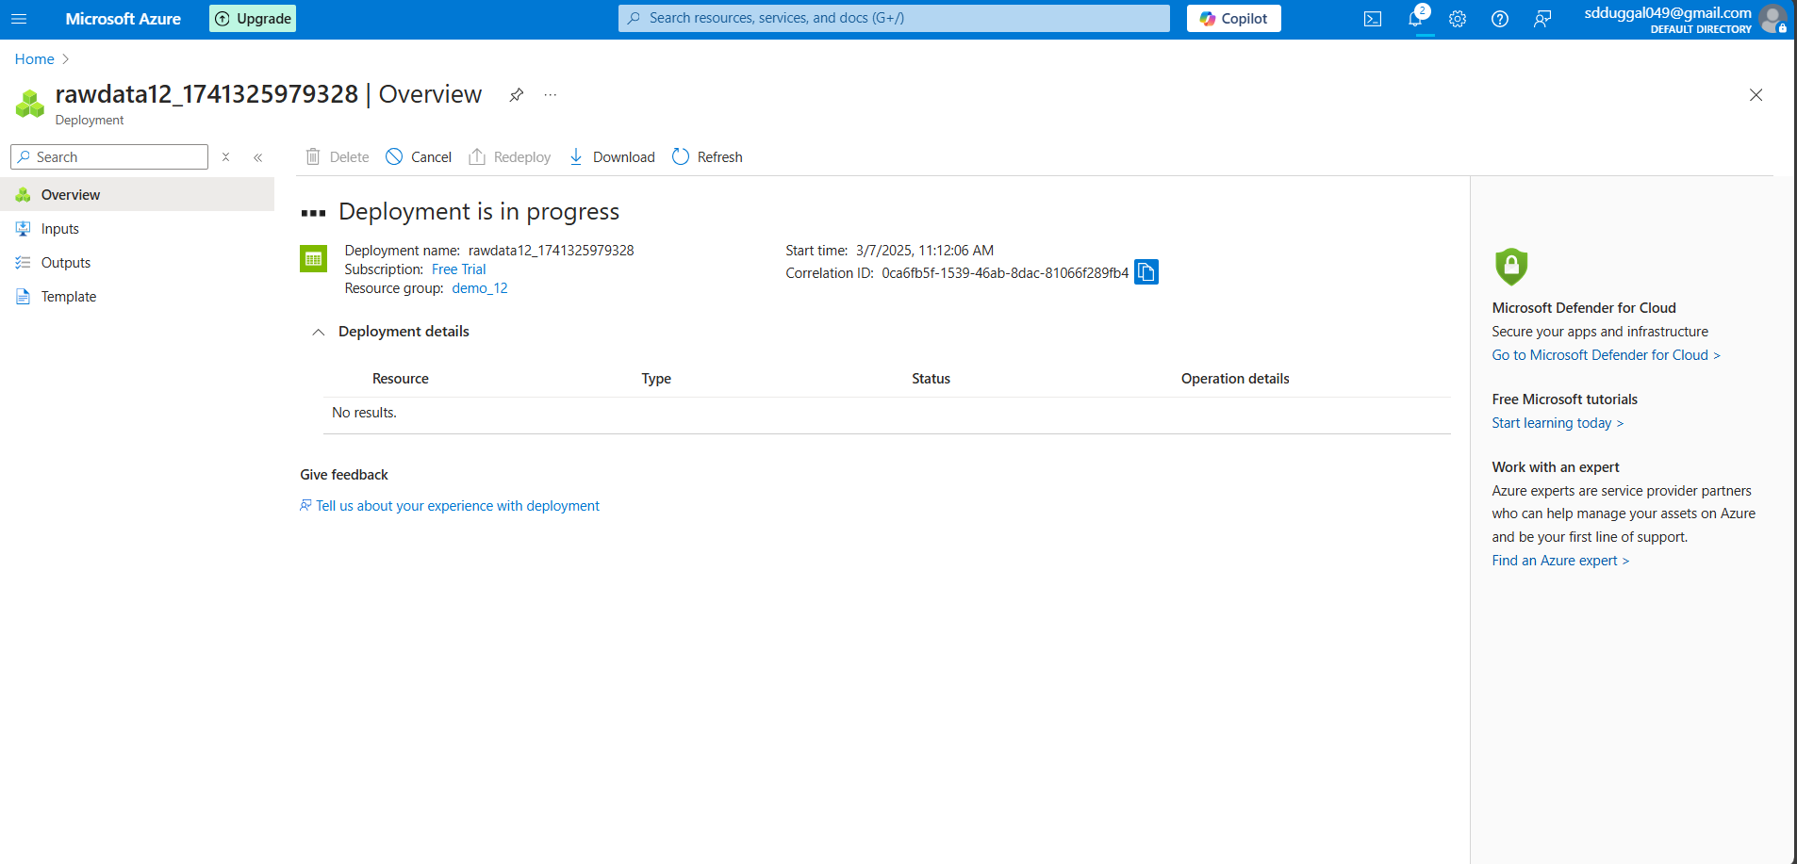

Cool Its created   
  
once it done it will look like this   
  
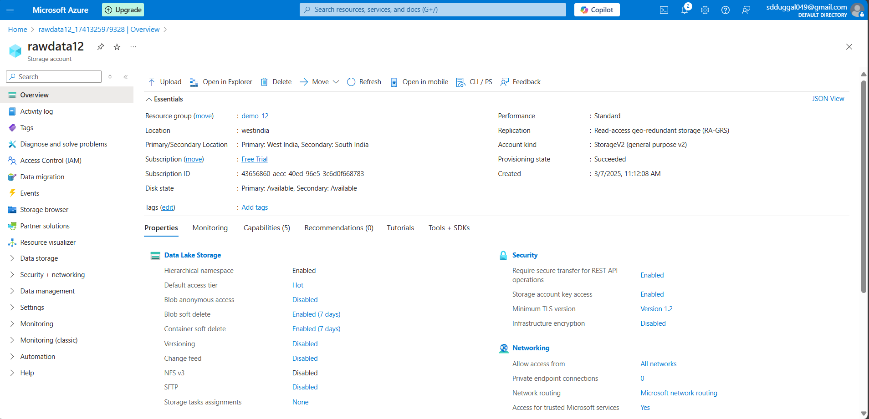

Small task   
  
Create a storage name called <yourname>_demo_stroage

In my case it’s akash_demo_storage